Civil Service Commission
Constitution Hills, Batasan Pambansa Complex Diliman, Quezon City

REQUEST FOR QUOTATION

RFQ No. | : | 2023-101
Date: | : | 6/7/2023
PR No./End-User | : | 2023-04-493 (CSLO)

Company Name Address :
:
:
:
:
:
:

Tel No. & Fax No.

Mobile No. / E-Mail
PhilGEPS Reg. No.

TIN No.

Please quote your government price/s including delivery charges, VAT or other applicable taxes, and other incidental expenses for the goods listed in
Annex A. Also, furnish us with descriptive brochures, catalogues, literatures and/or samples, if applicable.

If you are the exclusive manufacturer, distributor or agent in the Philippines for the goods listed in Annex A please attach in your quotation a duly notarized certification to this effect.

Prospective supplier who will submit a proposal with the lowest calculated and responsive offer / quotation shall be selected. As a condition for award, the selected supplier will be required to submit a copy of its updated PhilGEPS Registration or Mayor's / Business Permit, whichever is applicable, or both, as the case maybe. The updated *Certification Platinum Membership may be submitted in lieu of the Mayor's/Business Permit. If awarded, you will be required to submit a ‘duly notarized Omnibus Sworn Statement in accordance with the attached format (Annex B), together with the *signed copy of Purchase Order (PO) prior to the date of event / delivery / installation.

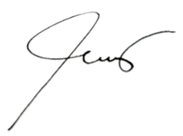
Please accomplish and submit this form and all the required documents to Procurement Management Division - OFAM, Basement, Civil Service Commission, Constitution Hills, Quezon City or fax it through number 931-8029 or email to csc.ofam.pmd@gmail.com not later than 21 June 2023 @ 3:00 p.m.
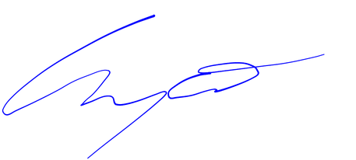

EDGARDO M. WYCO
931-7935; 931-7939; 931-8092 Loc. 508

SAM V. MANGLICMOT
Chief Administrative Officer
Office for Financial & Assets Management (OFAM)

TERMS AND CONDITIONS:
1. | Award shall be made on per: | Item Basis | Lot Basis | Total Quoted Price
2. | Goods/Services shall be rendered on
3. | Place / time of Delivery: | Civil Service Commission, Constitution Hills, Quezon City - OFAM - Lower Ground Floor / 8-12AM-1-4PM /  Agreed Time
4. | Please indicate Warranty:
5. | Technical specification with asterisks (*) are mandatory. For goods, please indicate brand, model and country of origin.
6. | Bidders shall provide correct and accurate information required in this form.
7. | Quotations exceeding the Approved Budget for the contract shall be rejected.
8. | Price quotation/s must be valid for a period of thirty (30) calendar days from the date of submissi |  |  | on.
9. | Terms of Payment: within 15-30 days upon complete submission of supporting documents.
10. | Payment shall be made through Land Bank's LDDAP-ADA (List of Due and Demandable Accounts Payable-Advise to Debit Account)./Bank Transfer Facility.
 | Account Name: |  | Account Number:
 | Bank Name: |  | Branch:
"Note: Non-Land Bank of the Philippines accounts shall be charged a service fee.
11. | Liquidated Damages/Penalty: amount of the liquidated damages shall be at least equal to one-tenth of one percent (0.001) of the cost of the unperformed portion for every day of delay. Once the cumulative amount of liquidated damages reaches ten percent (10%) of the amount of the contract, the Procuring Entity may rescind or terminate the contract, without prejudice to other courses of action and remedies available under the circumstances.
12. | In case of discrepancy between unit cost and total cost, unit cost shall prevail.
13. | In case of a tie, the contract shall be awarded to the supplier or service provider who first submitted its quotation.
14. | Prospective supplier must not be blacklisted by the PhilGEPS-DBM as appeared in their "List of Blacklisted Bidders".
15. | NOTE: "Prospective supplier must be registered at the Philippine Government Electronic Procurement System (PhilGEPS). You may visit the PhilGEPS website at www.philgeps.gov.ph and register for free."

Printed Name/Signature
Authorized Representative of the Service Provider

